Final Year Project - UG

**School of Computing Science and Engineering (SCOPE)**

B.Tech. CSE/CPS/AL AND ML Capstone Project IN HOUSE Weekly Status Report – Week_02- 12.12.2022 to 16.12.2022

**Program: B.Tech. CSE/CPS/AI AND ML** **Batch: 2019-2023** **Course Code: CSE1904**

**Register No.: 19BAI1090 Name of the Student: ARNAB KARMAKAR Mobile No. 9721866757**

|  |  |  |  |  |  |  |  |
| --- | --- | --- | --- | --- | --- | --- | --- |
| **Project Title: STOCK MARKET PREDICTION USING MACHINE LEARNING** | | | | | | | |
| Technical Implementation Steps & Programming Tools :   1. Simple Convolutional Neural Network - construction and generation of synthetic data from user defined input. 2. Python libraries related to Deep Learning (eg. Caffe, TensorFlow, Keras, sklearn-theano). 3. Deep Learning (DL) libraries used for synthetic data generation (eg. Datawig) that can work with both CPU and GPU. Integration of Datawig and HAM10000 using simple scalable container. 4. Basic Shell scripts for dependency installation. | | | | | | | |
| **12.12.2022** | **Explore the working and principle of GAN (CGAN and VAE – GAN) for the detection of images.** | | | | | | |
| **13.12.2022** | **Formulate the workflow of ACGAN** | | | | | | |
| **14.12.2022** | **Look for other similar ailments and types of skin lesions and how can data be generated using GAN.** | | | | | | |
| **15.12.2022** | **Study about Variational Auto Encoders as a solution to detect data imbalance.** | | | | | | |
| **16.12.2022** | **Study the working of GAN, and how is it a useful tool for synthetic data generation, and feed the training model with pictures.** | | | | | | |
| **Implementation** | Patent / SCI / Scopus Indexed Journal Paper / Scopus Indexed Conference Paper/ Scopus  Indexed Book Chapter | | | | | | |
| **Work Status** | ***Excellent*** | ***/*** ***Good*** | ***/*** ***Satisfactory*** | | ***/*** ***Needs improve*** |  |  |
|  | | | | |  |  |
| ***Attendance Status*** | **Regular / Irregular** | | | ***CAM – Max. 5 Marks per week*** | |  |  |

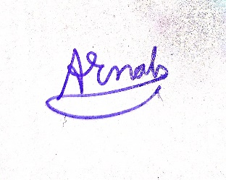

10/1/2023

**Signature of the Student with date** **Name & Signature of the Guide with date**